**Term III**

**SCIENCE AT HOME AND IN OUR COMMUNITY .**

**Water cleaning and purification.**

Water on the earth’s surface is affected by its surroundings which can make it dirty, polluted or contaminated.

**How water can get contaminated.**

1. Poor disposal of garbage and human body wastes.
2. Discharging industrial waste into water sources.
3. Dumping poisonous chemicals into a water source.
4. Salutation of soil particles into water sources.
5. Allowing animals to drink water from water sources.

**Hard water.**

1. Hard water is water that does not readily form lather with soap.

2. Water is said to be hard if I t contains a lot of mineral salts dissolved in it especially calcium salts.

**Disadvantages of hard water.**

1. it wastes soap.
2. stains kettles (water container)
3. blocking of hot water metallic pipes.

**Advantages of hard water.**

1. Provides mineral salts to the body.
2. Best for beer brewing.
3. Protect us from lead poisoning.

**How hardness of water can be removed.**

1. Boil the water.
2. Distillation of water.
3. Adding a calculated amount of lime.

1. **Preparing of safe drinking water.**

1. Decanting
2. Filtering
3. Boiling
4. Treatment using Chlorine.

**Decanting:**

1. This is a method where solid particles in the water are allowed to settle at the bottom of a container and water is then poured into another clean container.

2. Allow the water to stand still for several hours. So most of the suspended dirt settle at the bottom.

3. Carefully pour off the clean water leaving the settled dir t at the bottom of the container.

**Note:** The clear water collected is not yet safe for drinking because it may contain germs. It needs to be boiled.

**Filtering:**

1. Filtration is a method of obtaining clear water by removing dirt particles from it.

2. The filter paper is folded into a cone and fitted into the funnel.

3. The dirty water is now poured into the funnel so that clear water passes and the dirt particles

are held back by the filter papers as residues.

4. Filtering can also be done by using a clean piece of cloth.

**Boiling water.**

1. Boiling water helps to kill germs in water.

2. Boiling water makes it safe for drinking

3. To kill the germs the actual boiling should continue for at least 10 to 15 minutes.

4. The water should be allowed to cool but be covered to prevent dust and other dir t from entering it.

5. The boiled and cooled water should then be kept in clean containers so as to avoid any contamination.

**Treatment.**

1. Water needed in large quantities for use by many people in urban areas can not easily be boiled but it is purified by treatment.

2. Stages involved in water treatment.

1. Screening – removing weeds and other floating materials at the water intake from the source.
2. Sedimentation – removing impurities by letting water to settle.
3. Filtration – suspended dirt is removed from the water.
4. Chlorination – germs are killed by addition of chlorine chemical to the correct amount of water.
5. Storage – water passes to big reservoirs. It should be well covered to prevent contamination again.

(***Teacher should demonstrate and draw the diagram***)

**ACCIDENT AND FIRST AID.**

1. An accident is any occurrence that may result into injury.
2. First Aid is the first treatment an injured person gets before he is taken to hospital.
3. An injured person is also referred to as the casualty.

**Importance of giving first aid:**

1. First Aid help to save the life of the injured person.
2. First Aid is given to prevent germ infection through wounds and cuts.
3. First Aid is given to prevent over-bleeding.
4. First Aid is given to promote quick recovery.
5. First Aid is given to prevent further injuries.
6. First Aid is given to reduce pain.

BURNS AND SCALDS

**Scalds:**

1. A scald is an injury caused by wet heat.
2. Scalds can be caused by body contact with hot liquids.
3. Scalds can be caused by body contact with steam or vapour.

**First aid for scalds:**

Dip the effected body part in cold clean water where applicable and where not, pour clean cold water on the affected part.

**Effects of scalds:**

Scalds develop into wounds or body inflammations.

Burns

1. A burn is a injury caused by dry heat or by the reaction of chemicals on the body.

**Causes of burns:**

1. Burns can be caused by body contact with burning charcoal.
2. Burns can be caused by body contact with a hot metallic object.
3. Burns can be caused by body exposure to too much sunlight.
4. Burns can be caused by body contact with acid.
5. Burns can be caused by exposure of the body to X-ray radiation.
6. Burns can be caused by exposure of the body to radio-active materials.
7. Burns can be caused by exposure of the body to electric short circuits.

**Degrees of burns:**

Burns are categorized into First Degree burns, Second Degree burns and Third Degree burns.

**First degree burns:**

1. A burn is considered to be in First Degree if it affects only the first layer of the skin.
2. First Degree burns only cause a painful feeling in the effected part without causing any tissue damage. In extreme cases of First-Degree burns, the affected part may become inflamed.

**First aid of first degree-burns:**

1. Dip the affected part in clean cold water where applicable. Where it is not applicable, pour clean cold water on the affected part.
2. Cold water helps to reduce pain.

**Second degree-burns:**

1. Second Degree-burns affect the first and second layers of the skin causing minor damage to body tissues.
2. Second degree-burns cause blisters. Blisters are swellings filled with water. This water collects from body tissues during the accident.
3. Blisters should not be burst because bursting them opens the skin to germ infection.

**First aid to second degree burns:**

1. Dip the affected part in clean cold water where it is applicable. Where it is not applicable, pour clean cold water on the affected part.
2. Frequently give cold water to the casualty to replace the body fluids lost during the accident.
3. The drinks also help the kidney to quicken the process of removing toxins from the body in form of urine.

**Third degree burns:**

1. Third degree-burns destroy the entire skin and may destroy the surrounding body tissues.
2. In some cases, third degree burns may not show on the surface of the skin, but affect internal body organs. These are mostly caused by electric shock, drinking acids and in - halation of air with radioactive properties.

**First aid to third degree-burns:**

1. Prevent shock by lying the casualty in a reclining position with the slightly raised higher than other body parts to improve on blood circulation.
2. Frequently give the casualty cold drinks to replace body fluids lost during the accidents.
3. Cover wounds with a bandage or a clean piece of cloth to avoid germ infection.
4. Rush the patient to the nearest health unit for medical attention.

**Control and prevention of burns and scalds:**

1. Avoid sunburns by wearing white clothes covering the entire body whenever one is exposed to too much sunshine.
2. Cook in raised places to prevent accidental contacts with hot materials.
3. Acids and radioactive materials should be properly labeled and kept away from accidental contact.

FEVER AND CONVULSIONS

1. Fever is the condition caused by rise of body temperature above the normal.
2. The normal human body temperature is 370 C or 98.70 F.

**Possible causes of fever:**

1. Malaria infection can cause fever.
2. Viral infection such as influenza infection, small pox infection, chicken pox infection etc… cause fever.
3. Inflammations on the body cause fever.
4. High external temperatures above those that can be regulated by body mechanisms cause fever.
5. Severe body dehydration among infants can result into fever.

**Effects of fever:**

1. High fever can cause shock.
2. Fever beyond 410 C causes death.
3. High fever can result into failure of body organs.
4. Fever causes nausea, fainting and vomiting.
5. High fever in infants causes convulsions.

**First aid to fever:**

1. Apply frequent tepid sponging to cool down the body temperature.
2. Remove clothes to improve on air circulation around the body.
3. CONVULSIONS:
4. Convulsions are uncotrollable movements of body muscles due to disturbances in the cortex of the brain. OR: Convulsions is where body muscles contract and relax violently.

**Causes of convulsions:**

1. High fever in infants can result into convulsions.
2. Tetanus infection can cause convulsions.
3. Meningitis infection can cause convulsions.
4. An epilepsy attack causes convulsions.
5. Inadequate levels of blood sugar and calcium cause convulsions.
6. Cerebral malaria can cause convulsions.
7. Severe injuries on the head cause convulsions.
8. Too high levels of alcohol in the body can cause convulsions.

### First aid for convulsions:

1. Place the patient on the ground where there is enough space so that he does not knock himself against objects during convulsions. This can result into further injuries.
2. Remove the patient from the bed or raised place to prevent them from fall and hurting them during the convulsions.
3. Remove all loose clothing to prevent the patient from strangling himself during the convulsions.
4. Place a hard blunt object like a spoon between the upper and lower jaw to prevent the convulsing person from biting his tongue.
5. Lie the patient on his side to prevent him from choking on his vomitus in case vomiting.
6. If convulsions are caused by fever, apply frequent sponging to cool down body temperature.

**FAINTING:**

1. Fainting is the temporary loss of consciousness
2. Fainting is mostly caused by lack of oxygen in the upper part of the body especially the brain.

**Possible causes of fainting:**

1. Subjecting the body to too much heat or pressure can cause fainting.
2. Shock can cause fainting.
3. A sudden blow on the head can cause fainting.
4. Lack of glucose in blood can cause fainting.
5. Obstruction of the flow of blood in the upper part of the body.
6. High alcoholic levels in blood.

**Effects of fainting:**

1. Fainting can result into a coma.
2. Coma is the condition where the brain becomes dormant.
3. Coma may result into death.

**First aid for fainting**:

1. Lay the patient in a reclining position with legs raised above other body parts to increase on blood circulation.
2. Loosen tight clothes to improve on air circulation.

**NEAR DROWING:**

1. Drowning to die from lungs being filled with water.
2. Near drowning is the condition when lungs fail to carry out breathing due lungs being filled water.

**Places where drowning is likely to happen:**

1. Water bodies such as ponds, wells, rivers, lakes, oceans, etc….
2. Swimming pools.
3. Bathing tabs.
4. Water containers such as drums, pails, basins, etc….
5. Water reservoirs.

**How to help a person at risk of drowning:**

1. Call for help immediately.
2. If the victim is far inside the water body, extend a pole or oar for him to grasp as you row him ashore. Do not hold him because he may pull you into the water. Do not try to pull the drowning person into the boat because he may capsize it during the struggle.
3. If the drowning person is near the shore, extend a pole or throw him a line to pull him ashore.
4. Where you cannot move the drowning person because of injuries, use a floater to buoy him until more help arrives.

**First aid given for near drowning:**

1. If the casualty has stopped breathing, lay him face up and apply pressure between the abdominal and chest cavities to push out the water from the lungs.
2. Administer artificial respiration by doing mouth-to-mouth breathing ( Kiss of life).

**Prevention drowning accidents:**

1. Cover all pits and holes where water may collect.
2. Avoid playing in water especially without qualified instructors.
3. Keep containers filled with water out of reach of children.
4. Wear life saving jackets whenever travelling by water.

**POISONS:**

A poison is any chemical that can harm the body.

**Common causes of body poisoning:**

1. Eating food contaminated with Salmonella bacteria.
2. Drug over dosage.
3. Too much alcohol in the body.
4. Intentional or accident drinking or eating poisonous substances.
5. Snake bites.
6. Scorpion stings.
7. The organ of the body mostly affected by poison is the liver. The liver helps to remove or neutralize poisons in the body. Too much poisoning causes liver failure.

**First aid for poisoning:**

1. In case of snake and scorpion stings, rush the casualty to nearest health center.
2. In case of poisoning from over dosage, give the casualty a lot of milk or water to drink to dilute the drug.
3. In case of orally taking in any poison, give the affected person a lot of milk to drink to dilute the poison.
4. Give the patient water mixed with charcoal powder. The water helps to dilute the poison and the charcoal powder helps to absorb poison along the digestive lining.
5. Induce vomiting after giving the patient milk or water to remove some of the poison.
6. Where possible, give the patient juice rich in pectins. Pectins are chemicals in citrus fruits that have the ability to absorb toxins.

**ACIDS AND PETROLEUM PRODUCTS:**

1. Acid and petroleum products such as paraffin, benzene, petrol, etc… are accidentally taken into the body when they are mistaken for water.
2. Acids are corrosive and cause burns along the digestive tract.
3. Poisoning by petroleum products mostly affects the brain and the lungs.
4. Petroleum products damage the lungs and abstract movement of air through the windpipe.

**First aid acids and petroleum products:**

1. Where a casualty has taken acid, give him a lot of water to drink to dilute the poison. Do not induce vomiting as it may result into double tissue damage.
2. Where a casualty has taken a petroleum product, give him a lot of milk to drink to dilute the poison. Do not induce vomiting as it may lead to the products into the respiratory tract.

**FOREIGN BODIES:**

A foreign is any object in any part of the body where it does not belong.

**Foreign bodies in the eye:**

Foreign bodies in the eye may include metal pieces, dust, insects, etc….

**First aid Foreign bodies in the eye**:

1. If the foreign object is a metal, use a magnet to pull the metals out. Do not attempt to remove the pieces with a finger or a handkerchief as it may lead to the damage of the cornea.
2. In case of dust or an insect, rinse the eyes with water or use a handkerchief to remove the object.

**Foreign bodies in the nose:**

Children sometimes force objects such as seeds, stones, food, etc… into their nostrils. This can result into the blocking of air to the lungs.

**First aid Foreign bodies in the nose:**

1. Where the object is visible, use a pointed end of a handkerchief to remove the object.
2. Where the object cannot easily be moved, take the patient to qualified medical worker.

**Foreign bodies in the throat:**

1. Foreign bodies in the throat include chunks of food, coins, bones, etc… swallowed accidentally during feeding.
2. These objects often stick into the throat or enter the wind pipe causing choking.
3. Choking can result into suffocation.

**Acts that can result into choking:**

1. Talking while eating.
2. Swallowing food that has not been chewed properly.
3. Swallowing big chunks of food.

**People most affected by choking:**

1. Elderly people who have lost some of their teeth.
2. Young children with underdeveloped teeth.
3. Drunkards who misjudge the size of chunks of food they swallow.

**First aid for choking:**

1. Administer the epigastric thrust by standing behind the casualty and pressing the area between the abdominal and the chest cavities to force air out of the lungs. The air helps to push out the object from the windpipe or the throat.
2. Deliver gentle blows at the back while supporting the chest with the flat of your palm. This helps to push air upwards so that it pushes out the foreign object.
3. Use the finger to probe the object in the throat and remove it. This should only be done by doctors to avoid further injury.

**SANITATION:**

1. Sanitation is the general cleanliness to promote public health.

**Sanitation involves**:

1. Provision of good housing
2. Proper disposal of human wastes
3. Supply and use of safe water
4. Vector control
5. Safe guarding of food
6. Prevention of pollution of air and water.

**LATRINES.**

1. A latrine is a place for urination and defecation.

2. Latrines and toilets are very important because they keep feaces and urine in places where flies or other insects cannot bring them to our food and water.

**Types of latrines commonly used in Uganda.**

1. Traditional pit latrine

2. Ventilated improved pit latrines (V.I.P)

3. Toilets

4. Pottees

**Traditional Pit Latrines**

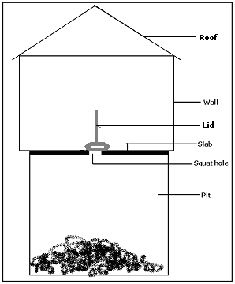

**Parts of a traditional pit latrine**

**A pit**

It should be deep enough to hold feaces of the user to many years. (usually 5 to 7 metres deep)

**A floor**

Strong enough to stand on and smooth enough to sweep and clean easily.

**A squat hole**

Big enough to allow feaces and urine to pass through but small enough to prevent children from falling through.

**A lid**

To cover the hole so as to control bad smell and movement of flies.

**Walls and a door**

For privacy.

**A roof**

To protect the floor and people from rain and sun heat.

**Disadvantages of a traditional pit latrine**.

It usually produces a bad smell.

**How to maintain a pit latrine**.

1. Smoke it regularly to control the bad smell.
2. The floor should be cleaned regularly.
3. Cockroaches in the pit should be sprayed.

**VENTILATED IMPROVED PIT LATRINE (V.I.P)**

**Features that makes it different from an ordinary pit latrine**.

1. It has a vent pipe
2. It lets out bad smell from the hole so that the latrine does not smell.
3. It has a screen / wire mesh. It is fitted on the top of the vent pipe to trap flies.
4. It has no lid. This is to allow free movement of air into the pit and up the vent.
5. It has spiral shaped walls with no door so that moving air can come through the pit and up the vent.

Note: **A VIP latrine is called ventilated because it has a vent pipe and improved because it doesn’t smell badly and it traps flies.**

**Diagram of a Ventilated Improved Pit latrine.**

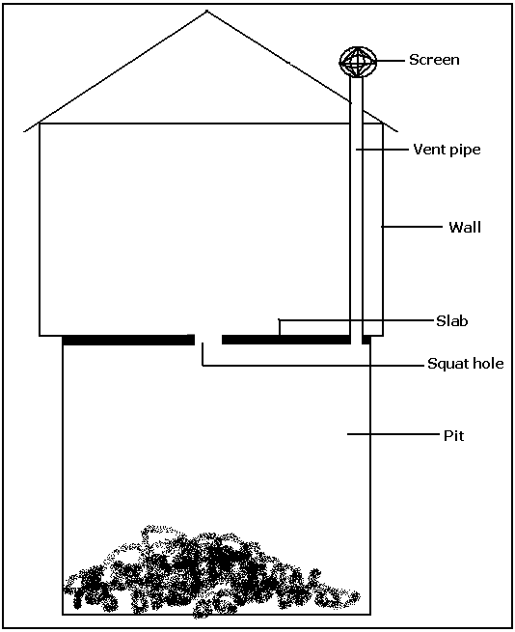

**Advantage of a Ventilated Improved Pit latrine**.

1. It does not smell
2. It traps flies

**The site for a p it latrine.**

1. At a lower altitude than a water source to prevent water contamination.

2. At least 30m away from any water source to allow the water which comes in contact with the feaces to filter out into the soil before it comes to a water source.

3. At least 10m away from a school, home , kitchen, hotel so that any bad smell does not r each people.

**Toilets (water closet latrine)**

1. They are found inside modern houses or buildings in cities, towns and places where there is supply of piped water system.

2. Toilets use water to flash waste matter into a septic tank.

**Parts of a toilet.**

**A bowl**

It is a basin containing water where feaces and urine is deposited.

**A seat**

It has a cover to protect it.

**A water closet (tank)**

It holds water for flushing.

**A handle**

We pull it or push it to flush the feaces and urine away down to the septic tank.

**Pipe**

Carry feaces to the septic tank.

**Septic tank**

It is where feaces and urine are stored until taken away be a cesspool emptier.

**Diagram of a Toilet**.

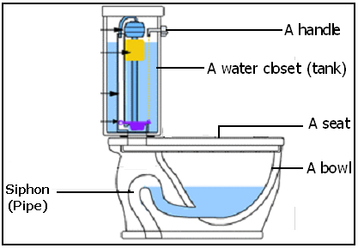

**Using a toilet.**

1. Flush the toilet always after use.

2. Wash hands after use.

3. Use toilet tissue whenever you visit it.

4. Avoid using hard materials like clothes, stones, hard paper because they block the pipe to septic tank.

5. Do not put any other thing in a toilet apart from feaces, urine, water and toilet tissue.

**Problems faced by urban toilet system.**

1. lack of water for flushing

2. they often block due to using hard things to clean one-self.

3. septic tanks spill out dirty water containing feaces all over the place.

**Maintenance of a toilet.**

1. Clean the seat with soap and disinfectants e.g Jik.

2. Scrub the inside part of the bowl using a brush.

3. Sweep and mop the floor.

4. Flash after us.

**THE REPRODUCTIVE SYSTEM**

**PUBERTY AND ADOLESCENCE**

**PUBERTY**

Puberty is the period of time when an adolescent becomes sexually mature.

**ADOLESCENCE**

* 1. Adolescence is the transitional period between childhood and adulthood.
  2. Adolescence on average begins at the age of 15 to 21 tears in boys and 12 to 21 years in girls.
  3. A boy or girl at this age is called an **adolescent**.

**Stages of adolescence.**

1. Primary sex characteristics
2. Secondary characteristics.
3. Psychological and emotional changes.
4. Out of step adolescent changes.

**Primary sex characteristics in adolescents.**

These are changes that involve sex organs in preparation for a reproductive function.

**In boys:**

1. The penis and the testes enlarge
2. Testes begin to produce sperms
3. One begins to experience wet dreams

**In girls:**

1. Development of the uterus and the ovaries
2. Production of ova by the ovaries
3. Menstrual cycles begin

**Secondary sex characteristics in adolescents**.

These are changes that are related to physical features that differentiate a mature man from a mature woman.

**In boys:**

1. Growth of hair on the chest, armpit and on the face.
2. The voice deepens.
3. Sweat glands become active.
4. Development of muscles.

**Note:** Increased levels of a hormone called testosterone bring about these changes in males.

**In girls:**

1. Development of breasts.
2. Growth of hair in the pubes and the armpit.
3. Enlargement of hips.
4. Active sweat glands.
5. Development of muscles and beautiful look.

**Psychological and emotional changes**.

1. These are changes that occur in one's mind and may not be realised by an adolescent.
2. They include:
3. Adolescents become interested in members of the opposite sex.
4. They want to look and be recognised as mature.
5. Move in peer groupings of boys and girls.
6. Become angry and disappointed quickly.
7. React quickly to different situations e.g. a boy or girl who was once docile and cooperative, becomes resistant and disobedient.

**Out of step changes**.

1. These are changes that occur differently to different in the same age group.
2. Some of these changes occur earlier or later than they are expected in some individuals.
3. They include:
4. A boy who was previously short may find himself taller compared to his age mates.
5. A girl who was once considered small may find herself too tall and too fat compared to her age mates.
6. Those who mature later may be influenced by those who mature early.
7. Anxiety may be created on those who mature later and left behind by their age mates.

**Problems of adolescence**.

1. This stage brings conflicts between adolescents and culture and religion.
2. This stage brings conflicts by adolescents wanting to experiment situations.
3. Makes adolescent to develop anti-social behaviours such as smoking, alcoholism etc.
4. Makes an adolescent gain forms of wished anxiety.

e) Brings conflicts between adolescents and elders

**Reproduction in humans.**

1. Reproduction is a process where living things increase in number. Humans undergo sexual reproduction.
2. This involve the union of the male and female reproductive cells.
3. These cells are reproduced by the male and female reproductive organs.

**The female reproductive organ.**

**Front view**

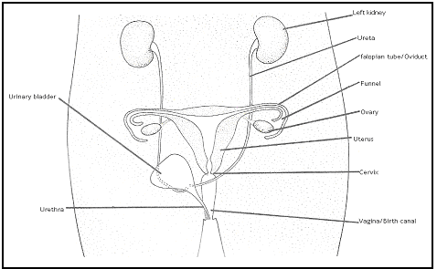

**Functions of different parts.**

**Vulva:**

Receives and directs the penis in the vagina.

**Vagina:**

a) It receives semen.

b) Italso acts as a birth canal

**Cervix:**

This is a ring of muscle that closes the womb during pregnancy or when it is not ready to receive sperms.

**Uterus:**

a) This is where conception or pregnancy takes place.

b) It is where the foetus develops from.

**Oviduct/ Fallopian tube:**

This where fertilization takes place.

**Ovary:**

1. Produces ova (female reproductive cells).
2. Produces hormones like Oestrogen which controls the secondary characteristics

**The male reproductive organ**.

***Diagram of the side view and front view of the male reproductive parts.***

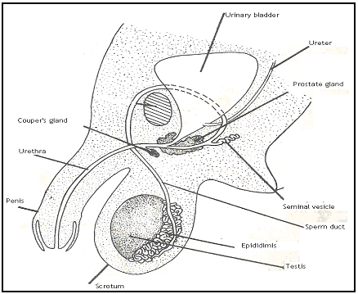

**Functions of different parts.**

**Scrotum:**

1. Protects the testes.
2. It hangs outside to prevent the sperms from being destroyed by too much heat.

**Testes:**

1. Produce sperms (the male reproductive cells).
2. Produce a hormone called testosterone which is responsible for secondary characteristics in boys.

**Epididymis:**

A coiled tube of about 6m long which stores already manufactured sperms.

**Sperm duct:**

Conducts sperms from the epididymis to the urethra.

**Seminal vesicle, Cowpers and prostate glands:**

1. Produce seminal fluid in which sperms swim.
2. A mixture of sperms and seminal fluid is called **semen**.

**Urethra:**

Conducts semen into the vagina during copulation.

**Erectile tissue:**

When stimulated, the numerous blood vessels will be filled with blood making the penis large and stiff.

**Penis:**

Used for penetration and to deposit semen into the vagina.

**Sheath/Fore skin:**

Covers the most sensitive part of the penis called the glans.

**Fertilization in humans:**

1. Fertilization is the union (fusion) of the male and the female gamete nuclei to form a zygote.

2. The male gamete is the sperm and the female gamete is the ovum

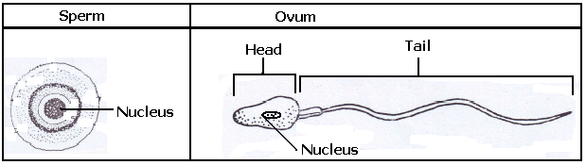3. Humans undergo internal fertilization.

**Internal fertilisaion:**

1. This is a type of fertilisation where the nuclei of the female cells unite with that of the male one inside the female's body.
2. This takes place when there introduction of semen in the female organs during the time of ovulation.

Ovulation is a process where the ovary releases a mature ovum into the oviduct.

1. Ovulation takes place every 12-14 days from the day of menstruation.
2. 2-3 hundred million sperms are introduced in the vagina in one ejaculation but only one is required to fertilize an ovum.
3. The act of inserting the penis into the vagina which results in the accumulated semen being ejaculated into the vagina is called copulation (mating).
4. A released human ovum is estimated to live for 12- 24 hrs. while a sperm can live in a female reproductive organ for 2-3 days.
5. When the nucleus of the sperm and ovum unite, a zygote is formed.

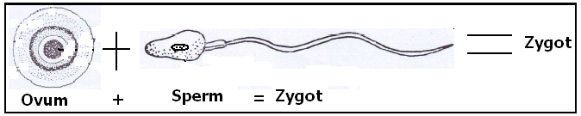

1. A zygote is a developing embryo between fertilisation to 8 weeks.
2. A foetus is a developing embryo between 8 weeks to birth.
3. In animals like rats, rabbits, dogs, pigs etc. many ova are relesed and are fertilised by a corresponding number of sperms.

**Menstruation.**

1. This is the monthly shedding of blood by the uterine walls whenever an ovum is not fertilised.
2. Usually, during ovulation, the walls of the uterus are thickened with layers of cells onto which the fertilised ovum attaches.
3. But if the ovum is not fertilised, the uterus walls break and shed off the blood, mucus and unwanted cells.
4. Menstruation occurs once in every 28 days.
5. It lasts about 3-5 days.

**Implantation.**

1. Implantation is a process where a fertilised ovum attaches itself onto the uterine lining.
2. After implantation, we say conception has taken place and that confirms pregnancy.

**Pregnancy/ gestation.**

1. This is a period from fertilisation to birth.
2. In man, it lasts 9 months.

**Common indicators of pregnancy.**

1. Monthly menstrual periods stop.
2. Breasts enlarge.
3. Morning sickness especially in the 2nd and 3rd month of pregnancy.
4. Enlargement of the belly.
5. Cervix closes.
6. Movement of the baby can be felt.

**Events in pregnancy.**

1. The fertilised ovum develops finger-like structures (villi) into the uterus.
2. The part with the villi develops into a specialised organ called a placenta.
3. The uterine lining under the influence of Oestrogen and progesterone develop rich supply of blood vessels to facilitate exchange of materials between the mother's and the foetus' blood.
4. Dissolve oxygen, glucose, amino aids and salts from the mothers uterine blood pass to the embryo while the carbondioxide and other nitrogenous wastes pass in the opposite direction through the umbilical cord.
5. A water sack called an amnion, which cushions it from damage, surrounds the embryo.

**Human foetus in the uterus.**

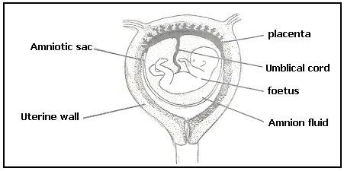

**Functions of different parts.**

**Umbilical cord:**

Contains an artery and a vein through which materials are conducted to and from the foetus

.

**An amnion:**

Holds the amniotic fluid.

**Amniotic fluid:**

Cushions the foetus from damage.

1. **The placenta:**
2. Acts as a food store and wastes.
3. Prevents the mother's hormones from reaching the foetus.

**Requirements by females during pregnancy.**

**Ante-Natal care:**

This is the regular visits to the medical personel by a pregenant woman. During these visits the following take place;

1. Treatment if sick.
2. Immunisation against tetanus.
3. Advice on the nature of the food to eat and the dressing during pregnancy.
4. Advice o doing exercise
5. Checking on the position of the foetus and the way it is developing.

**Good nutrition:**

Should eat a variety of foods mostly with proteins to ensure proper upkeep, better growth and development of the foetus.

**Physical exercise:**

Should have regular physical exercise such as walking, simple housework etc. but should not be given heavy work like lifting heavy loads.

Exercise keeps her fit in preparation for birth.

**Personal hygiene:**

Should ensure cleanliness in herself and the cloths she wears.

**Rest and sleep:**

Apart from the sleep at night, a pregnant mother requires adequate rest and sleep during the day.

**Appropriate dressing**:

Should be dressed in a martinet dress (free dress) and a brassier.

**Avoid self-medication**:

Shouldn’t take any drug unless prescribed by a health worker.

Some drugs are harmful to the growing foetus.

**Keep off from the patients:**

This is simply to prevent infectious and other contagious diseases.

**Common problems related to pregnancy.**

1. Morning sickness and vomiting.
2. Burning feeling or pain in the chest or stomach.
3. Lower back pain.
4. Swollen veins.
5. Piles and haemorrhoids.
6. Constipation.
7. Anaemia.
8. Swollen feet.

**Teenage Pregnancy**

Teenage pregnancy is pregnancy in a young woman who has not reached her 20th birthday when the pregnancy ends.

Teenage pregnancy may occur in marrieds or not married.

**Problems associated with teenage pregnancy.**

* + - 1. Dropping out of school.
      2. Parental and family rejection.
      3. Complication during pregnancy.
      4. The cervix is so weak to hold the foetus.
      5. Difficulty in delivering.
      6. Young mother may not take care of the baby properly.
      7. Community discremination.
      8. May fail to get married in the future. They are considered second hand.

**Family planning**.

1. Family planning is a measure taken by parents to have a manageable number of children.
2. This is usually achieved through birth control methods.
3. Birth control methods ensure child spacing.
4. Child spacing is where parents give adequate time between the birth of their family children.

5 **Importance of family planning.**

1. Enables the mother to regain her health in preparation for the next pregnancy.
2. Enables parents to have a manageable number of children in a family.
3. Enables children to have enough basic needs.
4. Checks on the population of a country.
5. Helps in the control of unwanted pregnancies.

6. **Some reasons why some parents produce many children.**

1. Ignorance about family planning methods.
2. High infant mortality rate.
3. Desire for a particular sex of a child.
4. Cultural beliefs and the need to show that one is sexually strong.

**Birth control methods.**

1. **Natural birth control methods**.

**Abstinence**:

This is a method where persons do without sex for an agreed period of time. This method is good for school going children and the unmarried.

**Breast-feeding:** Breast- feeding delays the re- occurrence of ovulation and menstrual periods. It's only effective if the mother breast-feeds frequently and for a longer time.

**Rhythm:**

This involves studying one's menstrual cycle and having sex only when ovulation is likely not to take place. It is effective in females with regular menstrual cycles. It calls for mutual understanding between the two partners.

**Withdrawal method**:

This is a method where a man pulls out his penis from the vagina before ejaculation. It's not effective because semen leak ahead of time for ejaculation.

1. **Artificial birth control method**.

**Use of contraceptive pills:**

Pills contain hormones that suppress (prevent) ovulation. This method is effective if the pills are correctly used as directed by the health worker.

**Birth control injections:**

This works in the same way as the pills. They also contain hormones that prevent ovulation and menstruation. Here, a dose of an injection is given for a long time (3-6 years).

**Use of condoms:**

A condom is a thin rubber made in different shapes to be used by both men and women.

**Use of IUD:**

* IUCD= Intra Uterine Contraceptive Device.
* IUD= Intra Uterine Device.

These are specially shaped plastic that are inserted in the uterus. This device prevents implantation of a fertilised ovum thus making conception impossible.

Some of the Intra-Uterine Contraceptive Devices

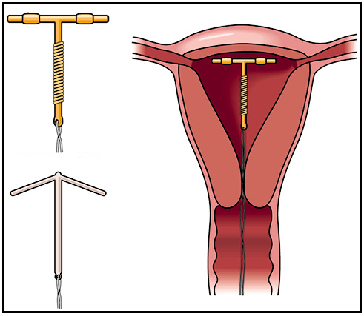

**Use of a diaphragm:**

This is a shallow cup made of rubber and worn by women before sexual contact. Unlike condoms, a cup can be used several times. It prevents semen from getting in contact with the female reproductive organ thus preventing fertilisation. The method is effective if it's used together with the contraceptive foam.

**Use of contraceptive foam:**

This is a chemical applied into the vagina an hour before sexual intercourse. The chemical kills sperms.

**Sterilisation method:**

This is a permanent method in which the couple will not have a child in their lifetime. The operation involves cutting and tying the oviduct and the sperm duct in females and males respectively. In males, the operation is called vasectomy and in females, the operation is called tubal- ligation.